|  |  |
| --- | --- |
| **NEW ZEALAND FOUNDERS SOCIETY INC.**  **Taranaki Branch**  Postal address: 34 Doone St., Lynmouth, New Plymouth 4310  Telephone: 06 7583750 or 027 5552331  Email: carol.c@xtra.co.nz  Web: www.nzfounders.org.nz |  |

Hello everyone,

**NEXT MEETING – Friday 9 August 2024 1.30pm New Plymouth Genealogy Rooms,**

**Moturoa Shopping Centre. access is off the Whiteley Street car park.**

**Our speaker is our member from Porirua, Peter Rankin.**

His great great grandfather, William Batten, was offered a section (No. 1133) by John Wicksteed in 1843.  Peter has put together a narrative about this which is now lodged with Puke Ariki. William Batten came to New Plymouth on the Essex ship.

There will be a raffle available at the meeting. $2 per ticket.

**Other news.**

**National AGM in June.**

Graham and I attended, after driving through torrential rain on the Friday, arriving in the dark, windscreen wipers going overtime and google maps on my cellphone giving directions getting quieter and quieter as my phone battery was getting low. Quite an adventure and I need to get a phone charger if we do long trips again.

Saturday turned out cool but fine thankfully. Our accommodation at the East Pier Hotel was stunning with lovely coastal views almost on the doorstep.

After the AGM we were able to participate in an organized coach trip which took us out through Havelock North to Hastings and back to Napier. Afternoon tea at the historic Duart House and walk around the museum and gardens there made for a lovely break from the meeting room.

The AGM went well. Most of the existing Officers were re-elected, with the only exception being the Membership/Administration Secretary roles being split back into two separate positions. Carolyn Adams has been doing both roles for several years and chose to relinquish the Administration position to focus more on our membership area.

I have been appointed as the National Secretary for the coming year.

The constitution was the big item on the agenda. It was passed unanimously by those in attendance and had 6 proxy votes against. Many thanks to those of our members who submitted a proxy vote. From memory, nationally there were 38 in total, and it is pleasing to see members taking an interest even if they can’t attend.

**The main changes to how we operate will be**;

The existing National Executive, including branch representatives will stay in their roles until the next AGM scheduled in New Plymouth sometime in March 2025. (All suggestions for this are welcome)

**Bank Account.**

Our bank funds will transfer to the National Account, clearly identified as Taranaki Branch funds, as from 1 January 2025. We will need to have 2-3 members identified to authorize expenditure for our branch. Payments will be made by the National body from our branch fund.

**Branch committee**.

There will be no requirement to have elected officers and committee at a local level after the end of this year.

We will need to appoint a National Representative to participate in the National meetings, currently held via teleconference every 6 weeks for the AGM in 2025. Currently, I am doing these roles.

We will also need to appoint someone internally to continue to organize our meetings and events.

**Subscripitions**

Subscriptions nationally will be set at the 2025 AGM in March. These will be paid to the National Office, referring to your name and Taranaki Branch. Our local portion of the sub will be credited to our Branch funds held by the National Office.

Going forward, the work will be focused on getting our day-to-day rules in place, procedures on how to do things, and developing the website to manage the Society affairs, provide better communication and access to more material to members.

As with all change processes, there will no doubt be a few hiccups along the way. I urge you all to provide feedback with any queries, concerns, or even better, positive comments so we can continue to improve.

**NEW MEMBER**

A warm welcome and certificate presentation was made to Jillian Williams, a new member who is very involved in genealogy in South Taranaki at our meeting at St. Andrews Church in Inglewood in May.

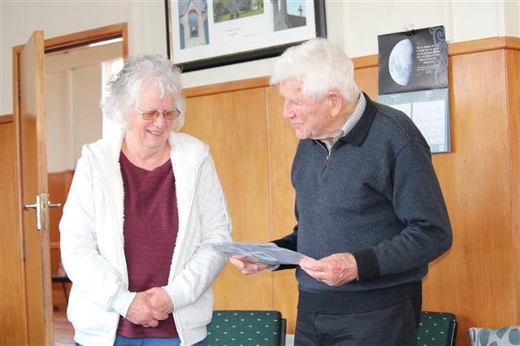

If you have friends, neighbours or know of anyone who may enjoy our events, please bring them along. The more the better if we want to grow our connections.

Looking forward to seeing you all on 9 August in the Genealogy Rooms.

Carol Cowling, (on behalf of your committee)